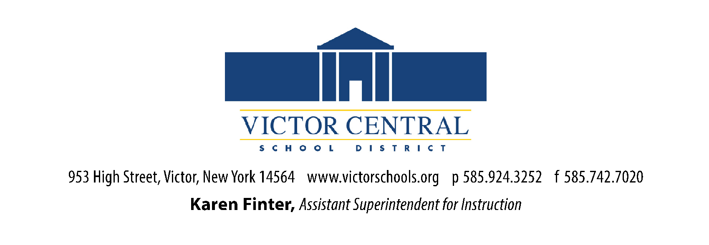
QUARTERLY REPORT GRADES 7-12
(Complete ONE form per student)
School Year: ____

Name of Student: ____________________________________
Grade Level: ___________ DOB: ___________ Age: _______
Parents/ Guardians Name: ____________________________________
Address: ____________________________________
City, State, Zip Code: ____________________________________
Email Address: _________________ Phone Number: _________

(Please check one of the following)
___ Quarter 1
___ Quarter 2
___ Quarter 3
___ Quarter 4 & please include annual assessment
information with Q4 report

Quarterly Report Beginning and Ending Dates: ____________ to___________

Number of Hours of Instruction This Quarter: _________________
(Please note: Minimum total hours are 247.5 per quarter/990 per year)

Days Present: _______ Days Absent: _______

We have covered at least 80% of our planned material this quarter: ___ yes ___ no

If no, please provide explanation in the space below:

____________________ _________________
Signature of Instructor Date

Please download and complete the forms. Email as an attachment.
Attach additional pages as necessary.

QUARTERLY REPORT GRADES 7-12 (continued)

School Year: ____

Subject: | Plans/Materials | Hours of Instruction  (hours per day x # of days) | Grade
English
Geography/History

Science
Math
PE
Health
Art (.5)
Music (.5)
Electives:

Total Hours of Instruction _________

